



Create a database named HospitalDB to store information
LAB MANUAL

Disclaimer: The content is curated from online/offline resources and used for educational purpose only
Create a database named HospitalDB to store information

Objective:
The objective is to create a database named HospitalDB containing two tables, Patients and Doctors, and to demonstrate various types of SQL joins (Inner Join, Left Join, Right Join, Full Outer Join, Cross Join, and Self Join) to manage and analyze the relationships between patients and doctors.
Problem Statement:
The hospital requires a database to store information about patients and doctors, including the relationship between them. The goal is to use SQL joins to retrieve meaningful insights from the data, such as matching patients with doctors, including unmatched records, and analyzing departmental relationships.
Requirements:
- MySQL Database installed (Workbench or Command Line).
- Basic understanding of SQL syntax and join operations.

Procedure:
Step 1: Start MySQL Server:
Open the command line or terminal.
On Windows: Use MySQL Workbench or run the mysql command.

Step 2: Create the Database
Execute the following SQL to create the database

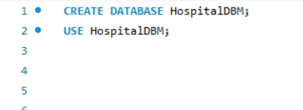

Step 3: Create the Tables
Define the table structure:

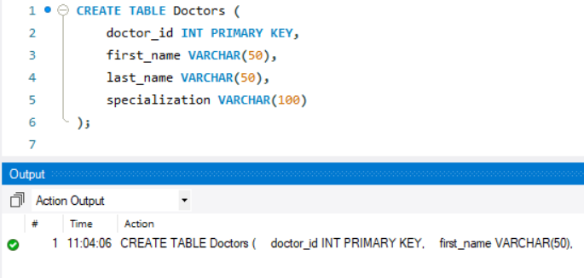

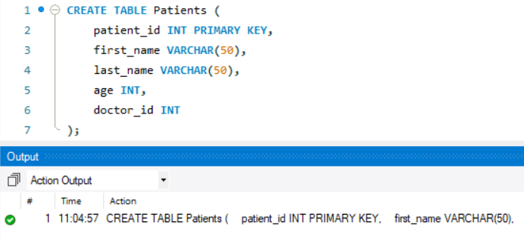

Step 4: Insert Sample Data
Add records for testing SQL operations:

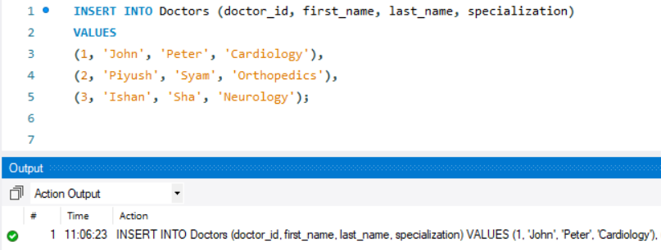
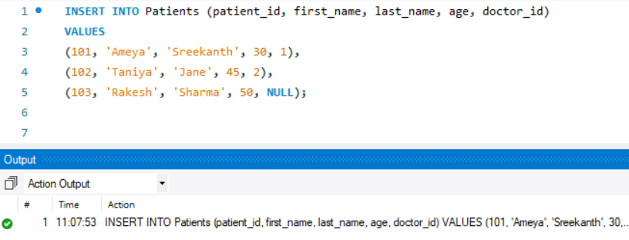

Perform the SQL Tasks
A) Inner Join: Retrieve Patients with Their Doctors
Write a query to retrieve a list of patients along with their corresponding doctor names using an Inner Join between the Patients and Doctors tables.
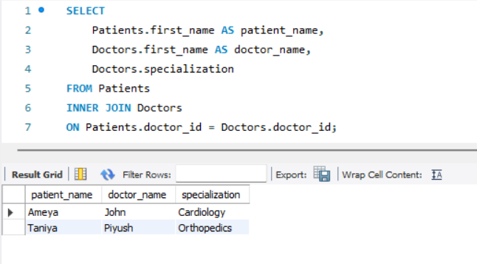

Retrieves only patients who have been assigned to a doctor. Filters records where Patients.doctor_id matches Doctors.doctor_id.

B) Left Join: Retrieve All Patients and Their Doctors
Write a query to retrieve all patients and their corresponding doctor names using a Left Join. Ensure that patients without doctors are also included in the results.

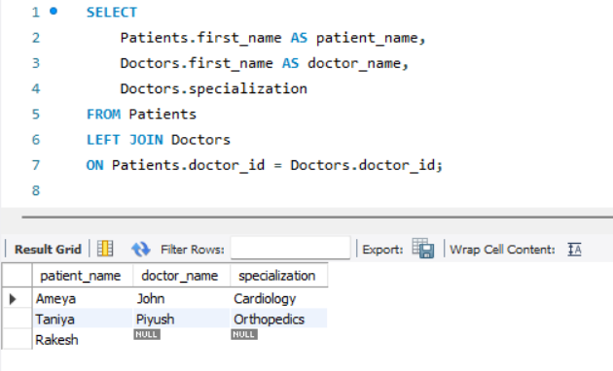

It retrieves all patients, including those without doctors. Then returns NULL for doctor details if a patient does not have a doctor assigned.

C) Right Join: Retrieve All Doctors and Their Patients
Write a query to retrieve all doctors and the patients enrolled with them using a Right Join. Ensure that doctors without patients are also included in the results.

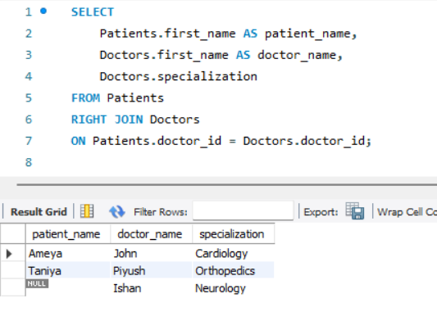
It retrieves all doctors, including those without assigned patients. Then returns NULL for patient details if no patient is linked to a doctor.

D) Full Outer Join: Retrieve All Matches and Non-Matches
Write a query to retrieve all patients and departments, showing all matches and non-matches using a Full Outer Join. Ensure that unmatched records from both tables are included.

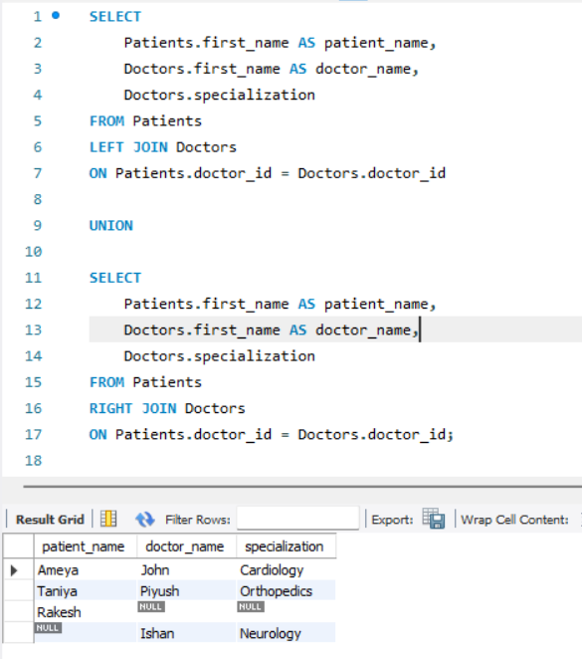

MySQL does not directly support the FULL OUTER JOIN syntax. Instead, you can achieve the same result using a combination of LEFT JOIN, RIGHT JOIN, and UNION.
In Left Join, it retrieves all rows from the Patients table and matches them with rows from the Doctors table.
Rows without a match in the Doctors table will have NULL values for doctor_name and specialization.
In Right Join, it retrieves all rows from the Doctors table and matches them with rows from the Patients table. Rows without a match in the Patients table will have NULL values for patient_name.
In UNION, it combines the results of the LEFT JOIN and RIGHT JOIN and Also ensures no duplicate rows in the final output.

E) Cross Join: Cartesian Product of Patients and Doctors
Write a query to retrieve a Cartesian product of the Patients and Departments tables using a Cross Join. This will show every combination of patients and departments.

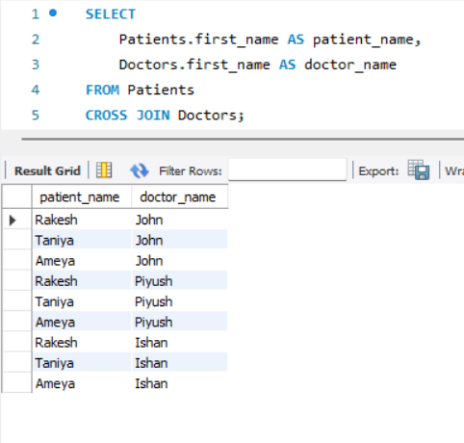
This combines every row from Patients with every row from Doctors. Then the results in a Cartesian product.

F) Self Join: Patients in the Same Department
Write a query to retrieve patients who are in the same department. Use a Self Join on the Patients table, showing their names and the department they belong to.

To perform a self join, assume we add a department column to the Patients table:
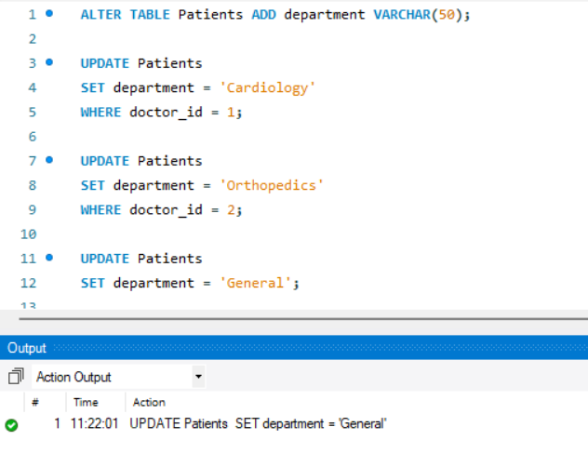

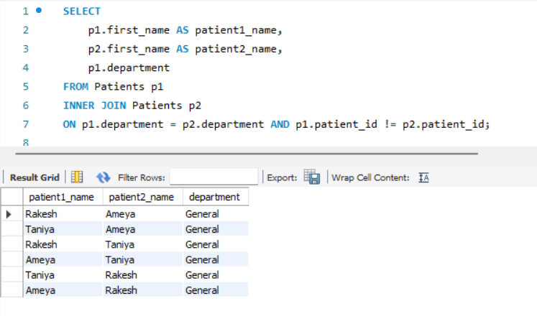
Joins the Patients table with itself to find pairs of patients in the same department. Then it ensures that a patient is not matched with themselves by adding the condition p1.patient_id != p2.patient_id.

Output:
The queries was successfully executed

